Your guide to the major types of White Wine
Never get embarrassed in a wine store again!
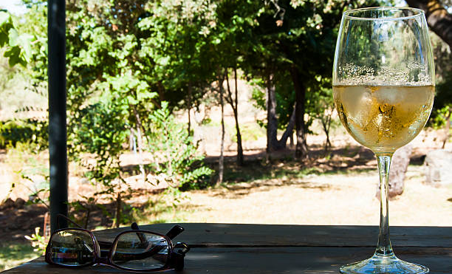
Let’s set the record straight, white wine is in no way less sophisticated than red wine. It can be just as complex, and just as delicious. It’s just about knowing exactly what you’re talking about when it comes to making that all-important wine order (in a totally non-pretentious way, of course)
How Is White Wine Made?
Typically, white wine is made using white grapes (duh!) But… like with everything in wine, it’s not quite as simple as just foot-stomping on some white grapes and ta-dah.
First off, the grape skins are removed prior to fermentation, to avoid imparting high levels of tannins, and colour into the wine.
This is different to red wine production, where the grape skins are left on during fermentation to ensure colours, flavours and tannins impart into the wine.
Hold up! What’s fermentation exactly?
Simply put, fermentation is the process where grape juices transform into alcohol. In other words, real-life magic.
“More scientifically, it’s when yeasts turn sugar into ethanol and CO2.” Christina says, “This can be carried out by natural yeasts which are found on the berries, in the vineyards and in the cellar, or by cultured yeast, which you can buy from laboratories.”
Not only is yeast crucial to the winemaking process, it also adds flavour and aroma.
The key to making white wine is fermenting for a period of two to four weeks at a low temperature of 12-22 degrees, to allow the delicate flavours, aromas and goodness to come through.
Once fermented, winemakers will often tweak the wine through choices such as maturing in old oak barrels or new oak barrels, which can bring vanilla or coconut flavours into the mix.
But wait, what’s the difference between old oak barrels and new oak barrels?
It literally means what it says on the tin! Old oak are barrels that have been re-used. Whereas the new oak are barrels that are yet to be used during wine production. The older the barrel, the less flavour they will impart.
After this, the goods are bottled up. Bottles that are sealed with a cork, over a plain screw top, usually undergo bottle ageing as a way of encouraging more complex flavours from contact with the cork and oxygen.
What Are The Most Common Types Of White Wine?
Christina says, “There’s no “one” Sauvignon Blanc, for example, but rather the taste of wines made from this variety differs depending on climate, soil, farming methods and most crucially – human interference or ‘’intervention’ in the winery.”
There are so many varieties. But we haven’t got all day! So, here’s eight increasingly popular varieties of white wine, you may or may not have heard of before.
Chardonnay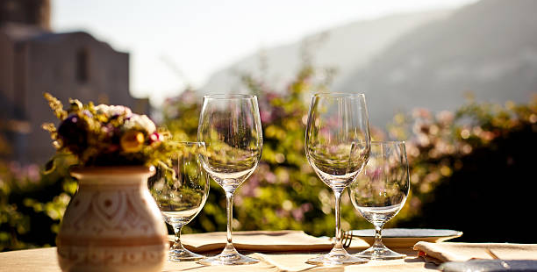
For a long time, Chardonnay was shunned by wine drinkers – a movement known as ABC (Anything But Chardonnay) made sure of that. But Chardonnay is one of the most complex and versatile grapes out there.
Medium to full-bodied, Chardonnay is a dry white wine that originates from the Burgundy region of France, and ranges in flavours from apple and lemon, to papaya and pineapple.
Best paired with meaty fish (cod, halibut) and shellfish (prawns, lobster, crabs).
Sauvignon Blanc
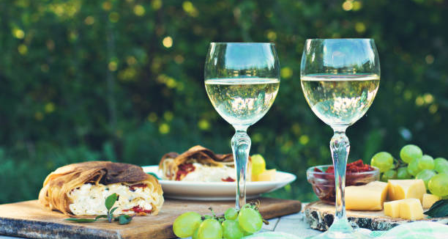
Packed with citrusy aromas, and balanced with perfumed, and acidic flavours, Sauvignon Blanc is often the go-to white wine for those who just don’t know what to have.
The green-skinned grape comes from the Loire Valley, but it’s often its New Zealand counterpart we see on menus – particularly from Marlborough.
Best paired with white meat like chicken, lightly seasoned vegetarian dishes and seafood.
Moscato
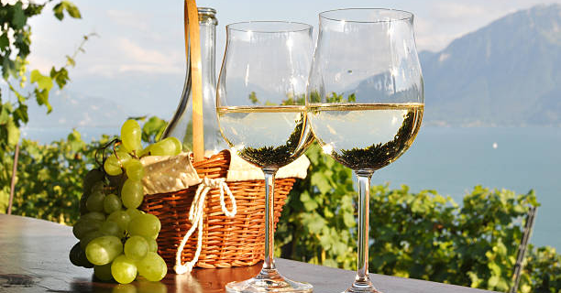
Sweet and fruity, Moscato has a hint of fizz, and is often used as a dessert wine. Most famously, it makes Asti Spumante, highly aromatic and perfumed with zippy acidity.
Best paired with crudités like carrots, celery and cucumbers.
Pinot Grigio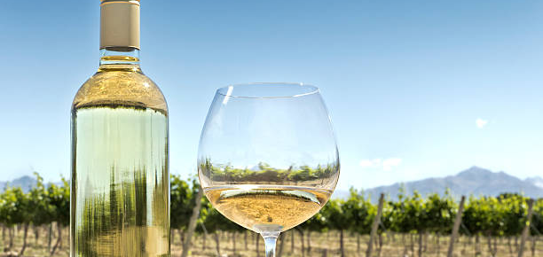
Also known as Pinot Gris, this wine is light-bodied, and bursting with fresh, floral aromas. Pinot Grigio is one the most popular Italian wine styles. Pinot Grigio varies wildly depending on where it’s grown – from the dry, saline varieties from Northern Italy, to the fruit-driven, lemony flavours of New World Pinot Grigios.
There’s even a sweet-style of Pinot Grigio made in Alsace, that uses noble rot and late harvest grapes (we’ll save this for another time) to create it’s candied, honeyed flavours.
Best paired with seafood, pasta dishes and vegetarian food.

Riesling
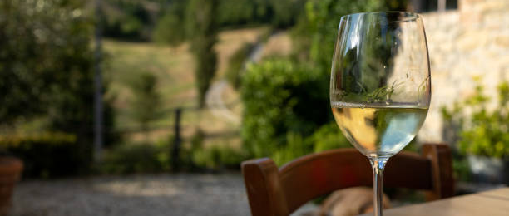
Riesling is an aromatic, perfumed and intense white wine. It’s a great option if you’re after something with some sugar, to counterbalance any spice, and can vary from super sweet to bone dry.
If you’re after a dry Riesling look for wines from Alsace, Washington State or Clare Valley. Germany has some great sweeter and off-dry Riesling styles.
Best paired with delicate fish, and Asian-inspired dishes.
Viognier
Viognier is a full-bodied white wine with beautifully perfumed aromas of peach, tangerine and honeysuckle. It originates from the Northern Rhöne region in Southern France and is often round, rich and intense in flavour, with an almost oiliness to the mouthfeel.
Best paired with grilled and roasted meats, and seafood.

Chenin Blanc
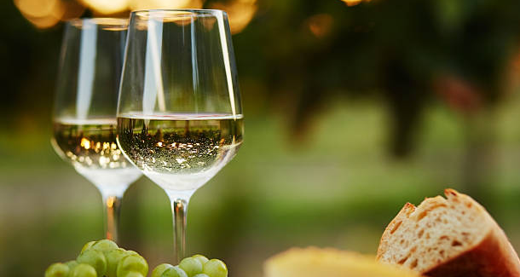
Chenin is super versatile, making wines ranging from dry, to sparkling. One of the most popular areas for Chenin Blanc is South Africa, where it’s often blended with Semillon, Viognier, and Marsanne to make a richer-style wine. It’s often described as having apple-like flavours and honeyed aromas. And has a good level of acidity and sweetness.
Best paired with sweet and sour foods. And Asian-inspired dishes.
Albariño
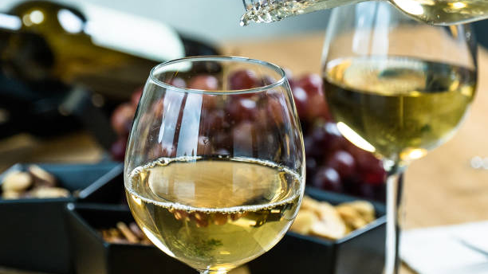
This wonderfully refreshing white, benefits from zippy notes of lime and grapefruit, matched with the stoned fruit flavours of nectarine, and even honeysuckle. Most Albariño comes from the Rìas Baixas region of Spain and the Vinho Verde region of Portugal.
Best paired with soft cheeses, salads and flaky fish.

