Your guide to the major types of Red Wine
Never get embarrassed in a wine store again!
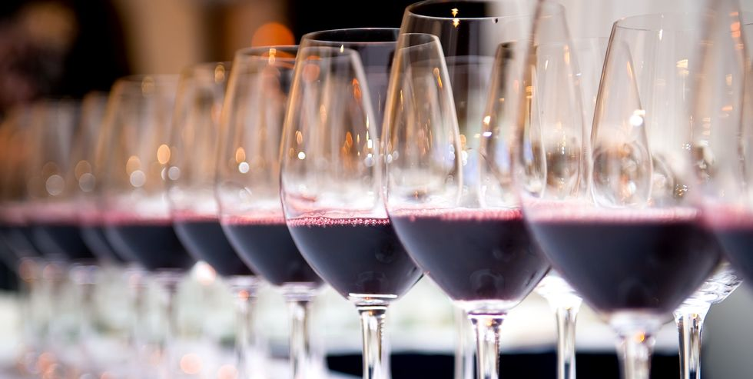

How many times have you found yourself mindlessly reading through a wine menu with a slight sweat appearing on your brow? The vast variety of wines and grapes you’ve never heard of before dancing across the page like a secret code.
It can be really tough to talk about wine, because the language around the liquid is full of jargon. With varietals and vineyards and vintages, tannins and terroir, it takes a whole lot of knowledge to sound sophisticated.
What actually is a Sangiovese? Or a Nebbiolo? Wait, are Shiraz and Syrah the same thing?
I hear you. I love wine, but I struggle to talk about it in fear of sounding like an idiot. But why should it be that way?
That’s why we’ve sought the help of an expert wine writer get the low-down on all things red wine. A great place to start is just identifying which wines you like. If you enjoy a glass of red but need some assistance figuring out which is which, here are a few of the major types you'll see over and over again. Find out how they taste, and which foods you should taste them with—so you'll sound just a little less daunted at your next dinner.

How Is Red Wine Made?
When it comes to making red wine, there are many things that come into play. But one of the most important factors is something called the maceration process. This is basically the process of how long the juice of the grapes stays in contact with the skins.
Rasmussen says, “Think of it like tea — the longer you leave your tea bag in the cup, the darker and more intense your tea will become. The more you squeeze the tea bag, the more tannins you’ll release into the tea, and that’s exactly the same for wine. It’s as if the fermentation vessel for red wine is a giant mug, and the grapes are loads of tea bags.”
The maceration period can last anywhere between 10 and 40 days, and it helps define the structure of the wine.
Wait! What does that mean?!
Well, look at it like this. A well-structured wine will have a balance of fruit, alcohol and tannins, and just enough acidity to make you crave another sip. Whereas a wine that lacks structure, may be more acidic, or taste a little too boozy. It’s basically about the relationship and balance between the different ingredients.
Rasmussen tells us that the structure is also dependent on how often the wine is moved around or ‘extracted’ during maceration. She says, “this can be done via several methods such as foot stomping or mechanical punch downs, which releases tannin, or ‘pump overs’ (moving the juice from the bottom of the vat back to the top).”
Tannins In Wine: What Are They And Where Do They Come From?
The all-important question. Tannins are bitter chemical compounds that live in nature. You’ll find them in everything from wood, to plants, walnuts, to grapes.
In wine, tannins come from the grape skins, pips (seeds), stems, or even the wood barrels that are used during aging. And they’re what gives wine its texture.
“Tannis are the textural, almost dusty or gritty element of a wine that you can feel on the inside of your mouth,” explains Christina.
Some wines will have less tannins than others. For example, white wine tends to have less tannins than red. This is because the wine-making process is different for each style of wine. During red wine production, there’s a great deal of contact between the juice and the crushed grape skins and seeds (remember the maceration process?). But for white wine, the juice is separated from the grape skins and seeds immediately after the grapes are crushed, which means less tannins are released.
What Are The Most Common Types Of Red Wine?
“Taste is inextricably linked to our own personal memories, so don’t be intimidated by wine tasting notes, but rather embrace your own feelings, memories and culture,” recommends Christina. “Perhaps a wine reminds you of your grandmother’s perfume, or maybe it tastes like a certain spice you use in cooking. Wine language should be celebrated for its individuality and uniqueness.”
But the world of wine is vast; over 1,000 grape varieties are used for the production of wine, and as you might have already guessed, we’re not going to list every single wine variety (c’mon, that would be absurd).
Instead, here’s eight increasingly popular varieties of red wine, you may or may not have heard of before.
Cabernet Sauvignon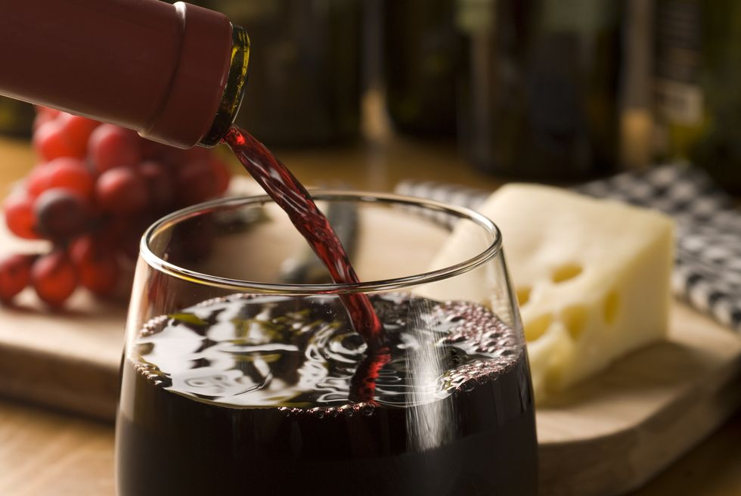
The most planted grape in the world is cabernet sauvignon, and it's a safe (yet sophisticated!) bet to order at just about any meal to please the whole group. While California Cabs can be a bit fruitier, and French Cabs a bit more herbal, a glass is always interesting to drink as you look for notes of cherries and currants, as well as spices.
Drink with: just about any meat, especially if it's fatty. A Cabernet Sauvignon would be delicious with a burger, short rib, or lamb.
Merlot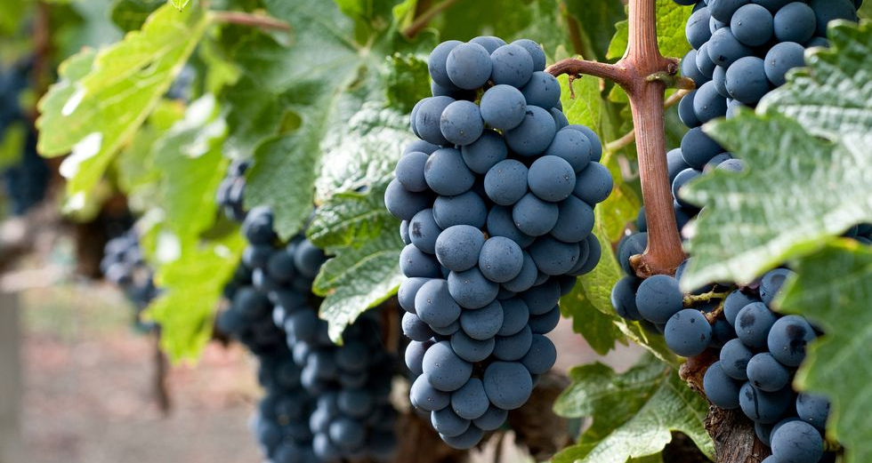
Merlot is the second-most planted grape, and it's a great entry point for someone trying to get into red wine. The wine is really "easy" to drink, meaning it's fruity and yummy and won't make your mouth pucker up with tannins.
Drink with: poultry, like duck or chicken.
Zinfandel
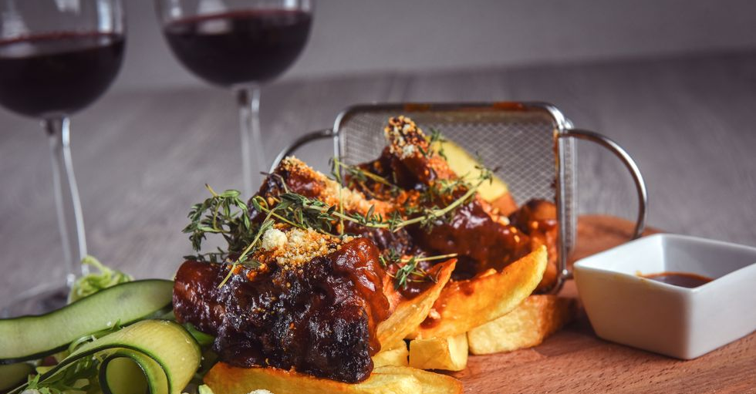
For some reason (the marketing campaigns of the 1990s), Zinfandels are often associated with moms. Which is OK! Moms are great, and they have awesome taste: Zinfandel is an interesting wine because the taste can really vary based on where it's grown, though it's usually nice and juicy and high in alcohol content. Imagine juicy, spicy strawberries that get you smashed.
Drink with: meats like pork ribs, or pizza and pasta dishes.
Syrah/Shiraz
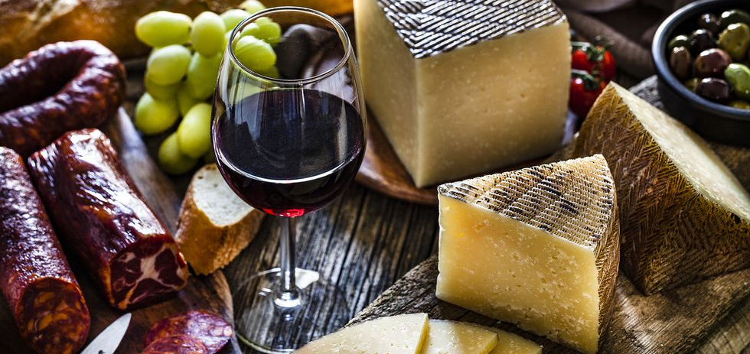
Called Syrah in France and other European countries, and Shiraz in Australia, South America, and elsewhere, this wine is just plain fun to sip on—it can be peppery, spicy, and bold, with the flavour of rich fruits like blackberry. Break this one out after a long day when you want to sit with a book and a glass of wine and really taste something.
Drink with: a charcuterie plate, because it'll play off all the salt and spice and subtle flavours in the cheese and meats.

Malbec
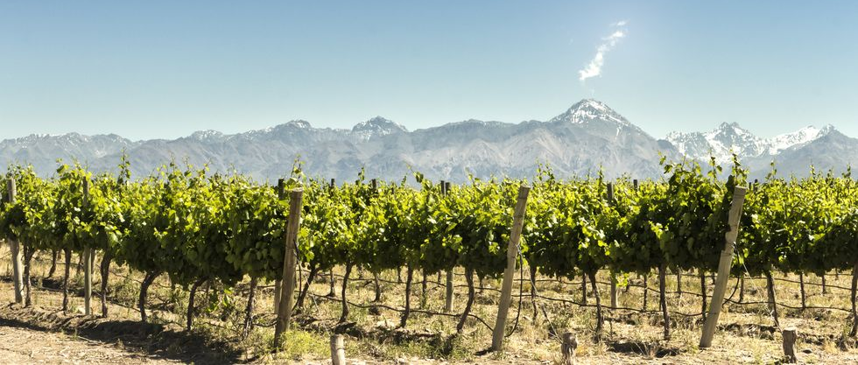
Though it's French in origin, most of the world's Malbec is now produced in Argentina so you may often see that country on its label. It's another easy drinking wine, with a deep purple colour and plum or cherry flavours, ending in a hint of smoke. It's another crowd-pleaser.
Drink with: leaner meats like flank steak, or spicier food like Mexican or Indian.

Pinot Noir
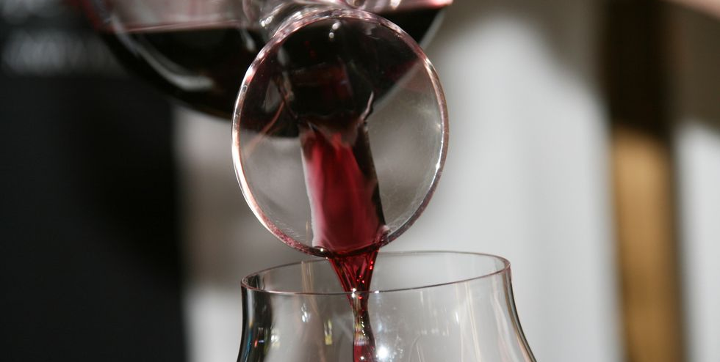
Among the lightest and most delicate wines with this hue, Pinot Noir won't punch you in the face like some reds can; it has a "light body" in the lingo and feels silky to the tongue. You might taste bright berries like raspberry or cranberry.
Drink with: sushi or salmon. Yes, you can drink red wine with fish!

Sangiovese
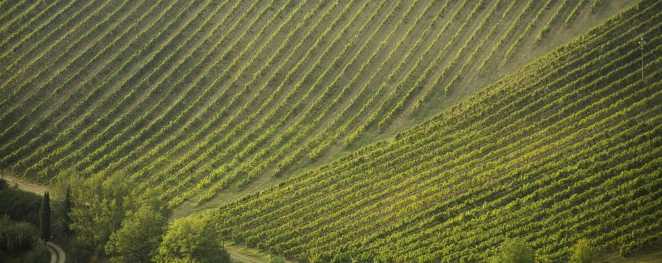
Ciao, vino bello! Sangiovese is the biggest red grape in Italy and is associated with Tuscany—specifically, Chianti. Here's a wine that will do weird things to your mouth, as the acids will make it water and the tannins will stick to the sides. You might also taste tobacco, soil, and pepper. There's a whole lot going on with this one!
Drink with: pizza and pasta. Of course!

Nebbiolo
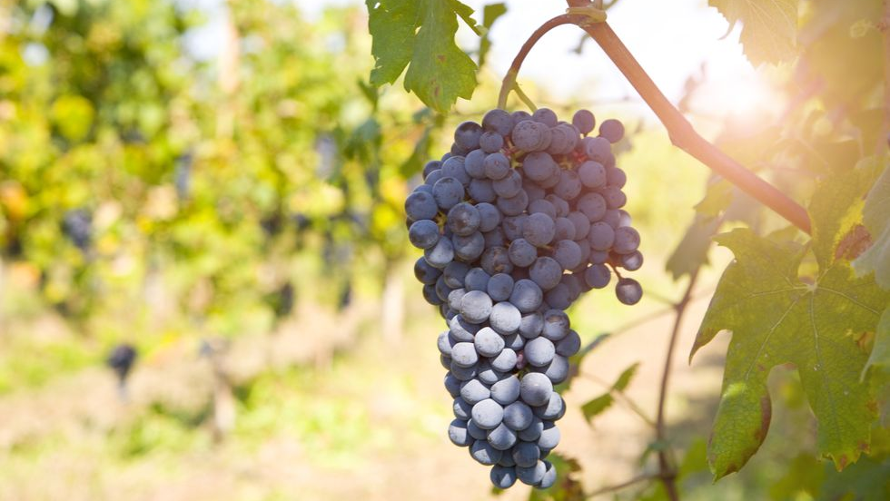
Another Italian favourite, Nebbiolo also has strong tannins and tons of acid. It's a tricky wine, as the light colour belies the insane flavour coming to smash you. It's grown in northern Italy and is the grape behind the infamous Barolo and Barbaresco. The flavours of this wine get more interesting and complex as it ages, which is why it's a great one to splurge on... and then save for a special occasion.
Drink with: gamey, fatty meats like wild boar, goose, duck, pork shank. Basically, this is what you'd drink if you'd just won a battle in the Middle Ages and were enjoying a celebratory feast.

